Date:
Subject : Science
Topic: Force and Pressure
Grade: VIII

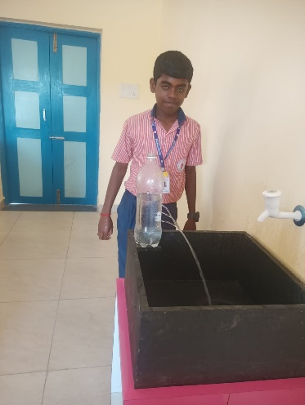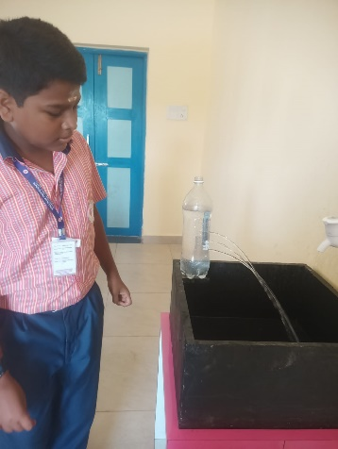

Learning Objective : Liquid pressure differs at different heights

